BHRAMANN: Travel to Conquer Space and Time

REPORT

On

INDUSTRIAL TOUR

March 19, 2018 – March 25, 2018



**JAIPUR ENGINEERING COLLEGE & RESEARCH CENTRE**

**Organised by:**

**Department of Electronics &Communication Engineering**

**JECRC, Jaipur**

**TOUR – MAP**

**JAIPUR**

**CHANDIGARH**

**MANALI**

**KURKSHETRA**

**AMBALA**

**TOUR – PLAN**

**Day 1 (March 19, 2018):** Departure from Jaipur to Kurukshetra by Train (Overnight Journey)

**Day 2 (March 20, 2018):**  Kurukshetra to Manali by Bus (All Day Journey), Stay at Snow Park Hotel in Manali

**Day 3 (March 21, 2018):** Manali to Gulaba Snow Point by local conveyance, Solang Valley, DJ Night, Stay at Hotel

**Day 4 (March 22, 2018):** Manali sight-seen, Overnight Journey to Chandigarh

**Day 5 (March 23, 2018):** Check-in into Clarion Inn Hotel in Chandigarh, Industry visit, DJ Night, Stay at Hotel

**Day 6 (March 24, 2018):** Chandigarh sight-seen plus Market, Departure from Chandigarh to Jaipur (Overnight Journey)

**Day 7 (March 25, 2018):** Reach Jaipur in the Morning

**FACULTY- COORDINATORS**

1. Ms. Aapurva Kaul
2. Mr. Ashish Sharma
3. Mr. Bhoopesh Kumawat
4. Ms. Preeti Barot
5. Ms. Shivam Upadhyay

**TOUR-AGENCY**

Shikhar Travel

**STUDENTS**

Total Number: 51

**Department wise:**

ECE(41)

CS (3)

IT (2)

ME (1)

CE (4)

**Gender wise:**

Girls (24)

Boys (27)

**TOUR ITINERARY**

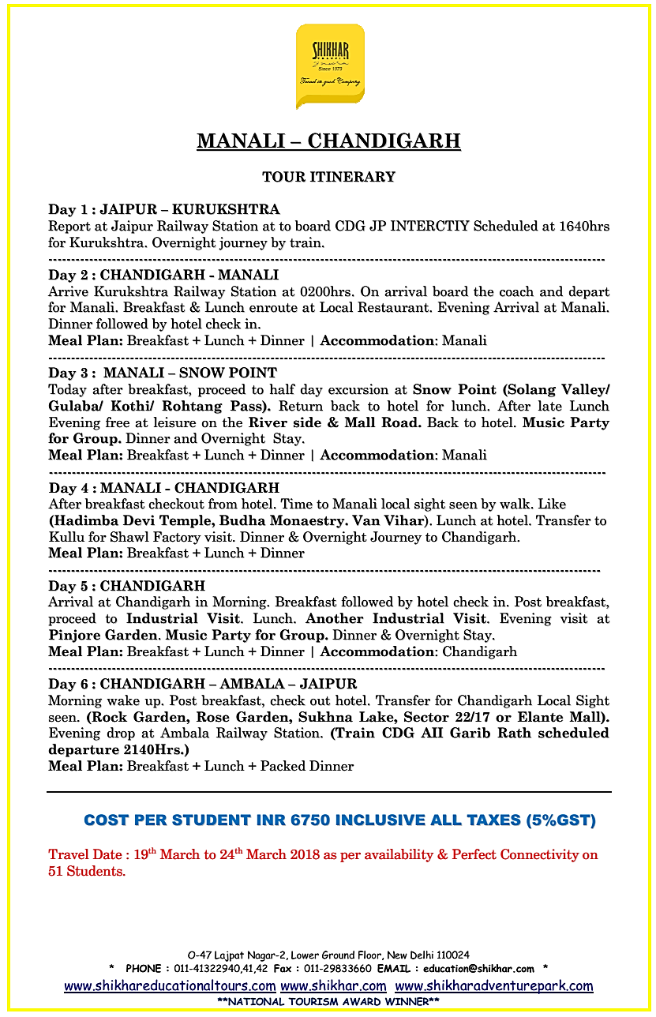

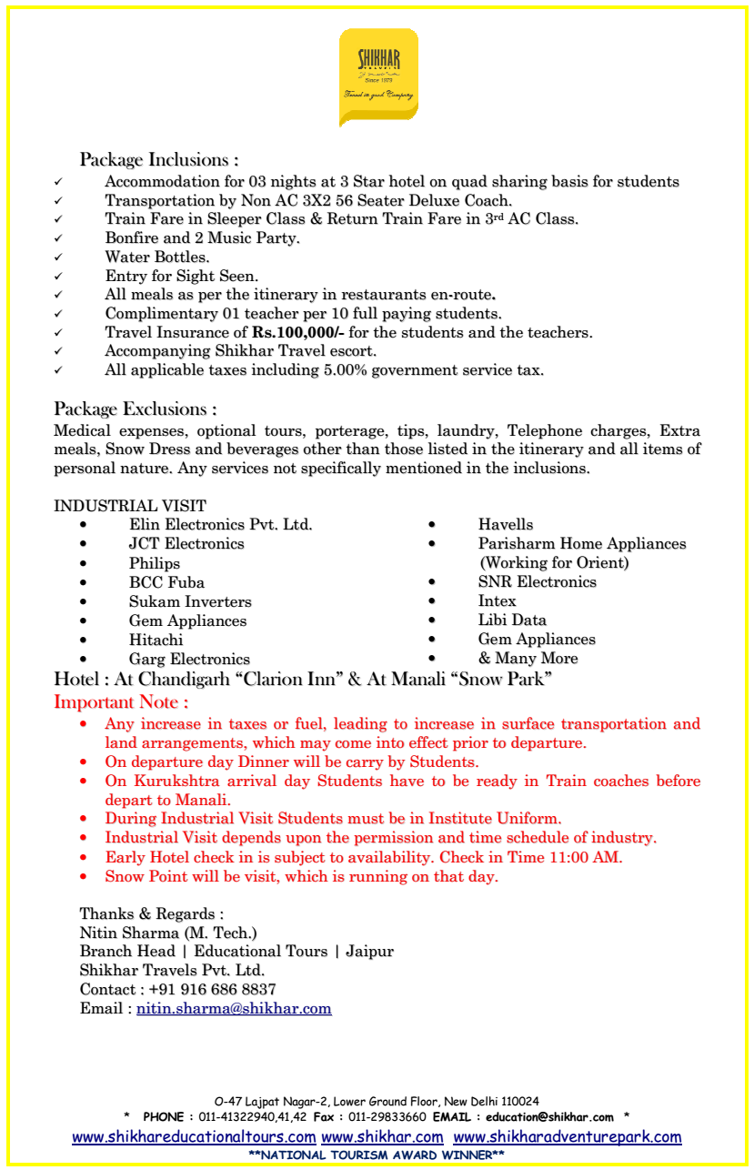

**TOUR BANNER**

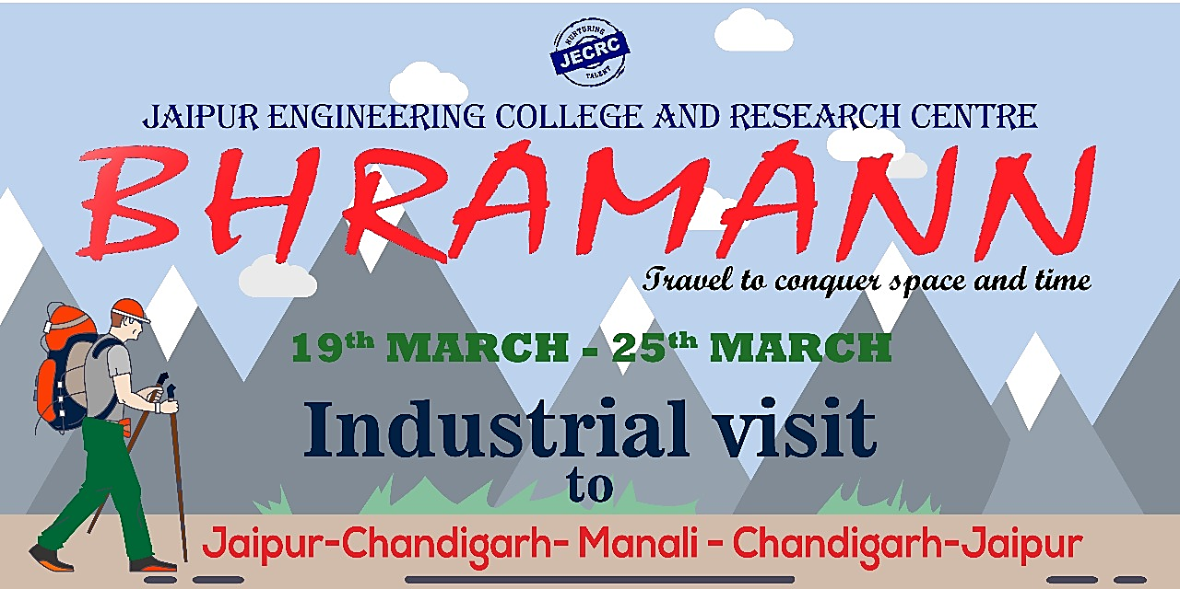

**TOUR T-SHIRT**

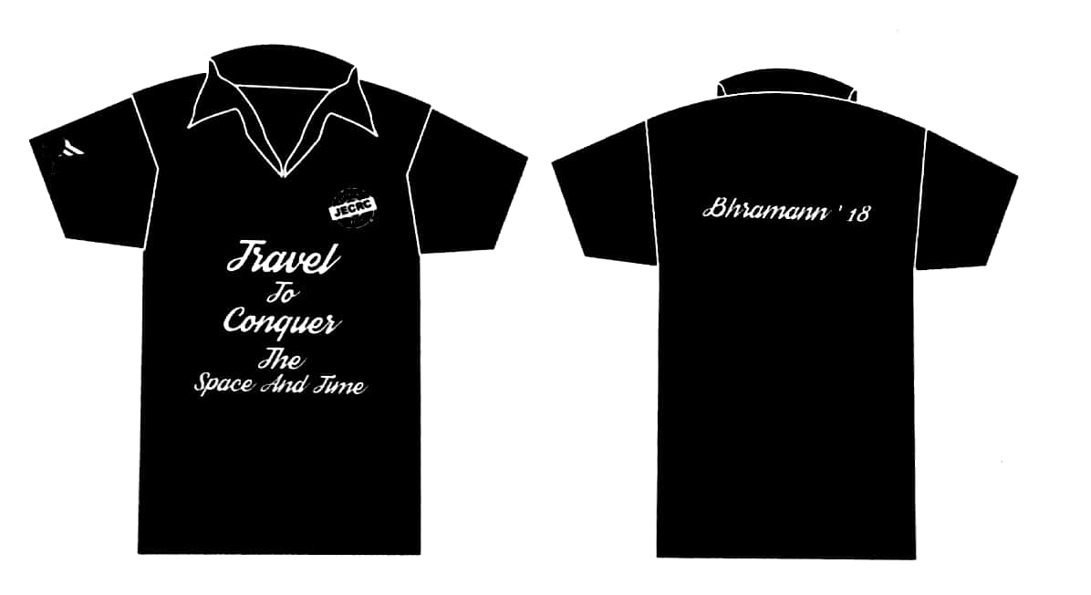

**TOUR-DETAIL**

**Day 1 (19.03.2018)**

* Assembled at Gate No. 2, Railway Station Jaipur, Main Junction at 3:00 p.m.
* Moved to Platform No. 2 with all 51 students and 5 faculties
* Train departed for Kurukeshtra at 4:40 p.m.
* Train arrived Kurukshetra Station at 2:30 a.m.
* Way to Manali by Bus (Via Chandigarh)

**Day 2 (20.03.2018)**

* Had breakfast at 7:30 a.m. and departed for day-journey at 9:30 a.m.
* Had lunch en route at Hotel Panchwati (Bilaspur,H.P.)3:30 P.M.
* Checked-in hotel Snow-Park in Manali at 10:30 P.M.
* Had dinner at 11:00 P.M.

**Day 3 (21.03.2018)**

* Had breakfast at 8:30 A.M. in Snow Park
* Departure from hotel for Gulaba Snow-Point at 10:00 A.M.
* Rented snow-dresses and other coverings and reached Gulaba
* Students enjoyed snow-fall and back to hotel via Solang-Valley
* Had lunch in hotel and took rest till evening
* DJ night was arranged from 7:00 P.M. to 10:00 P.M. followed by dinner

**Day 4 (22.03.2018)**

* Had breakfast at 8:30 A.M.
* Enjoyed the cloudy and rainy-view of manali
* Departure from hotel for local sight-seen i.e. Hadimba Temple, Ghatotkach Temple, Buddha-Monastery and Van-vihar
* Students enjoyed a lot on river-side
* Went for Shopping in Mall road, Manali
* Reached Hotel and had lunch at 5:00 P.M.
* Depart for Chandigarh thereafter at 7:30 P.M.
* Had delicious dinner en route

**Day 5 (23.03.2018)**

* Checked-in Hotel Clarion-Inn in Chandigarh early morning
* Took breakfast at 8:30 A.M.
* After taking breakfast, left the hotel for Industry visit
* Firstly visited **Philips Lightings** and then after visited **Talent Pull** in Mohali.
* Reached back to hotel and had lunch.
* Students enjoyed DJ night followed by dinner at 10:30 P.M. in hotel.

**Day 6 (24.03.2018)**

* Took breakfast at 7:30 A.M.
* Went to Yadavindra Garden Pinjore- followed by Rock-Graden and Sukhna Lake
* Had lunch at a restaurant in sector-22
* Enjoyed the rest of hours in shopping at sector-22 market
* Depart for Ambala Cant. Railway Station at 7:30
* Came back from Ambala by Gareeb-Rath to Jaipur
* Took dinner in train as food packets

**Day 7 (25.03.2018)**

* Reached Jaipur-Junction at 7:30 A.M.

**INDUSTRY VISITS**

1. **PHILIPS LIGHTING: Light beyond Illumination**

**Address:** Industrial Area, Phase 9, Sahibzada Ajit Singh Nagar, Punjab 140308

**Overview:** Philips is taking lighting beyond illumination with connected lighting innovations for the home, retail environments, offices, cities, and more. Philips pioneered the development of high-quality, energy-efficient LED lighting. Philips is now taking lighting into a fully digital world that connects people, places, and devices.

**About CFL:** A compact fluorescent lamp (CFL), also known as a compact fluorescent light or energy saving light,is a type of fluorescent lamp. Most CFLs are designed to replace incandescent lamps and fit into mostexisting light fixtures.

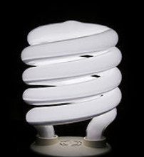

There are two main parts in a CFL: the gas‐filled tube and the magnetic or electronic ballast. Anelectrical current from the ballast flows through the gas (mercury vapour), causing it to emitultraviolet light. The ultraviolet light then excites a phosphor coating on the inside of the tube. This coating emits visible light.

**Visit Pictures**

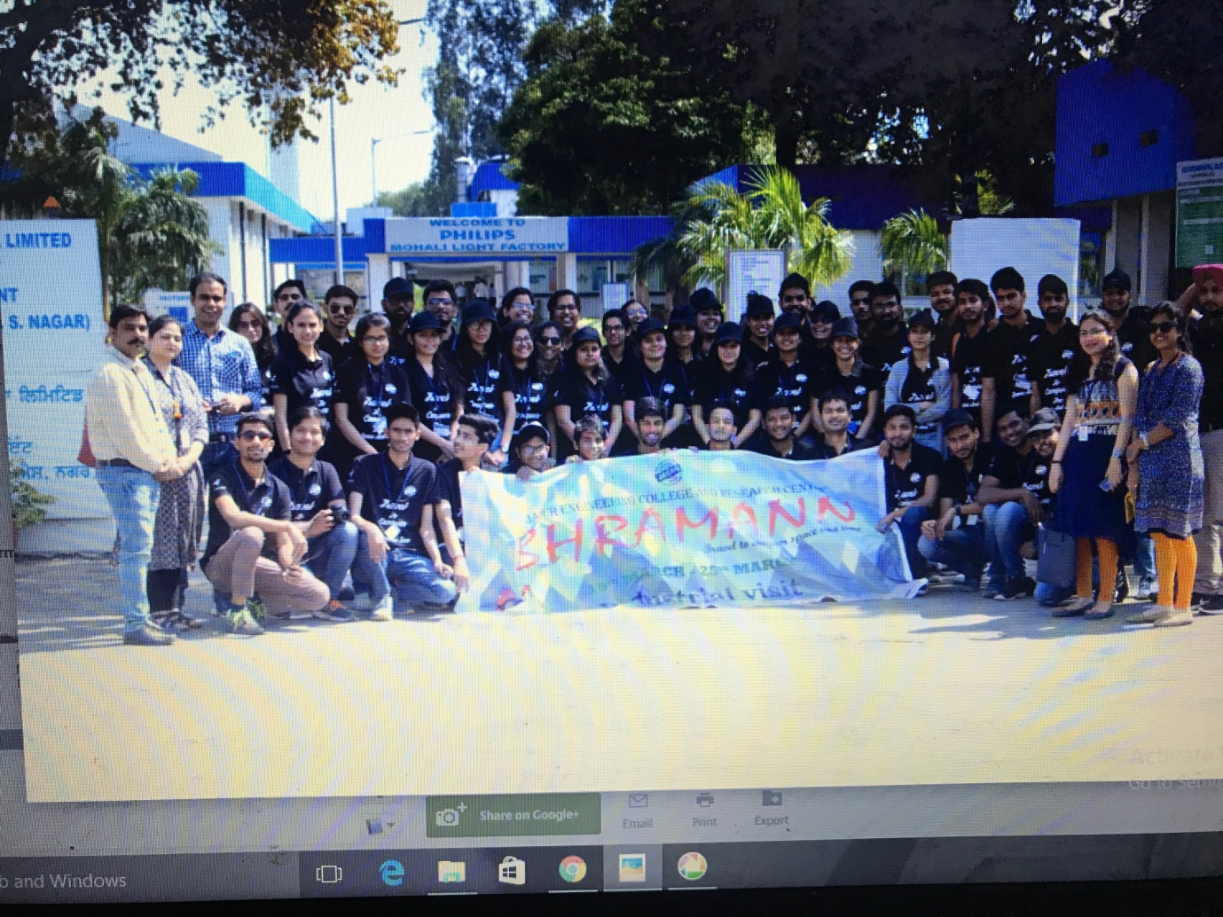

1. **TALENTPULL: Service Excellence**

**Address:** Gillco Valley Road, Sector 127, Sector 4, Main Bazar, Sahibzada Ajit Singh Nagar, Punjab 140301

**Overview:** Talent Pull was established in the field of manpower outsourcing, recruitment & Project Management work. They are providing requisite manpower requirement of various Companies in India to their entire satisfaction. It is a one- source multi-resources organization. They had provided their services to all type of Industries Telecom, FMCG, Real Estate, Finance, manufacturing, IT etc.

Their strength is well trained/experienced staff who are specialized in Payroll and talent hunt i.e. identifying and sourcing candidates from the exact companies in India who are engaged in similar business related to their clients.

**Working Areas in Telecom Sector**

The company provides Network Services to Telecom Operators/Tower Companies through following services:

* Wi-Fi Network Services
* Video Surveillance Services
* Installation & Commissioning
* Operation & Maintenance (24x7)
* Offshore Service Delivery
* Consulting Services
* In-Building Solution
* Microwave Engineering
* RF Optimization
* Benchmarking Services
* RF Planning & Design

**Visit Pictures**

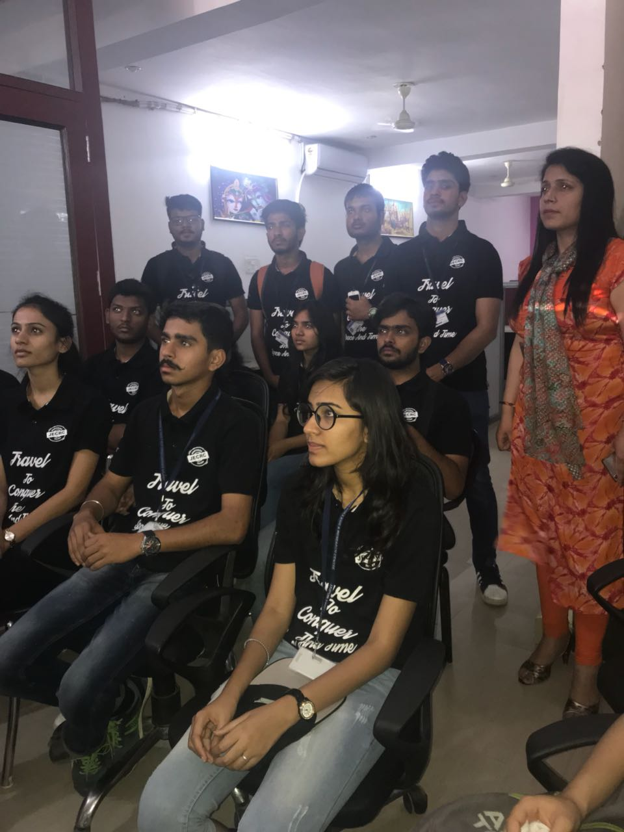

Student Interaction Session at Talent Pull

**REMINISCENCES**

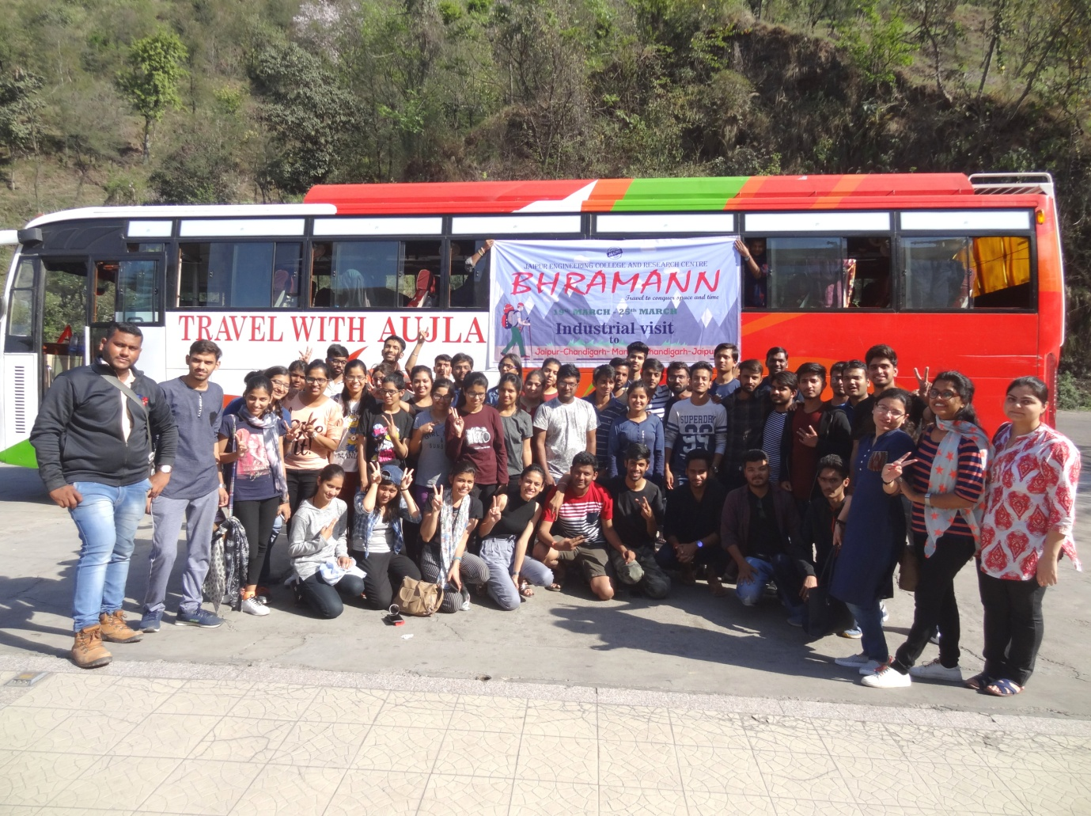

Student during enroute lunch (Chandigarh to Mnali)

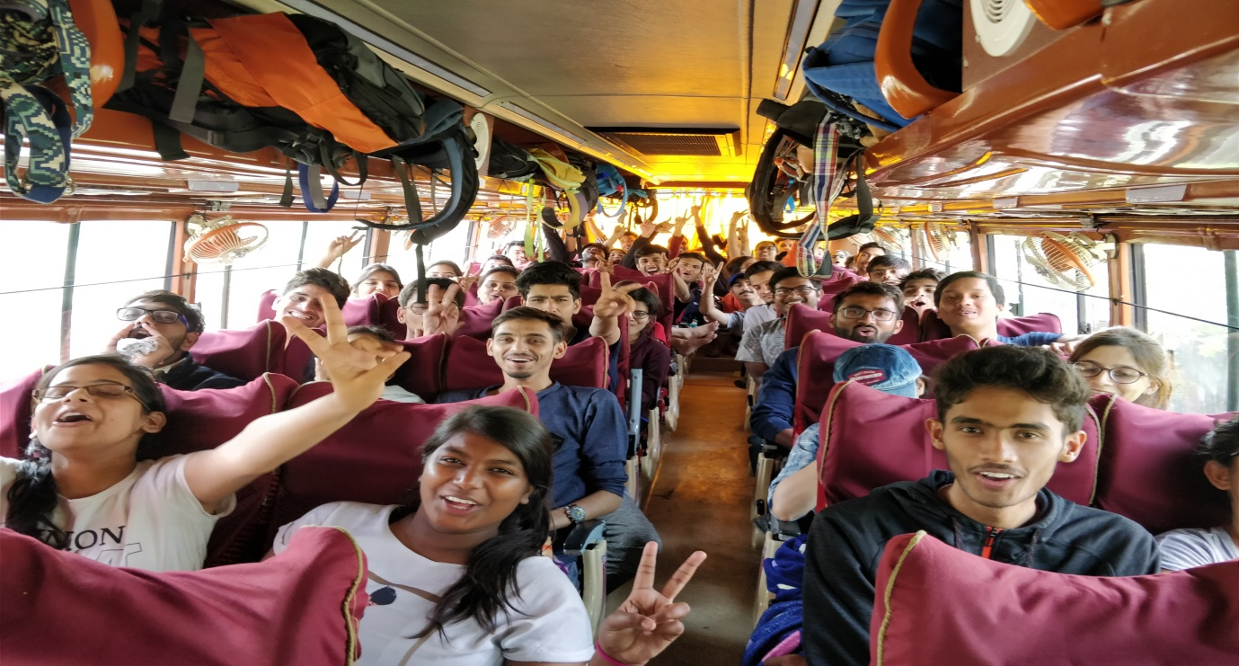

Fun in bus

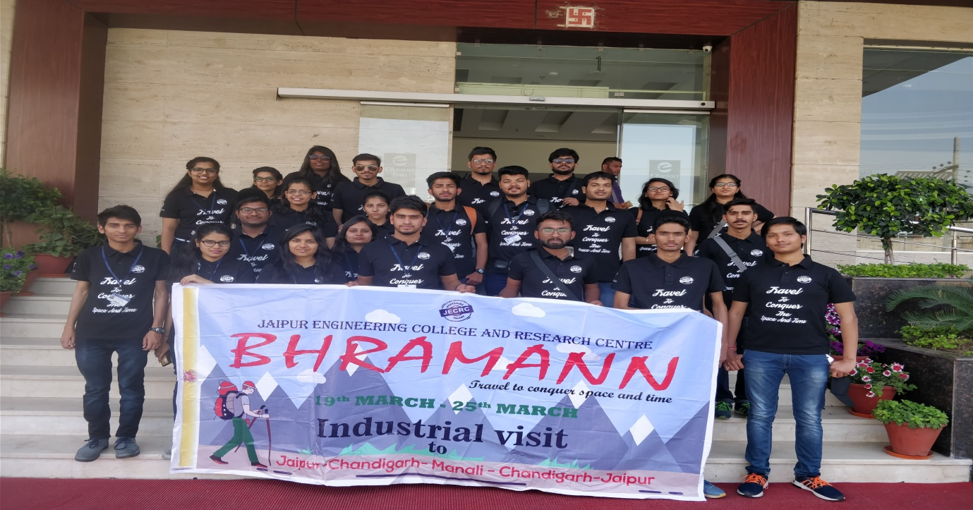

Student in Clarion INN Chandigarh

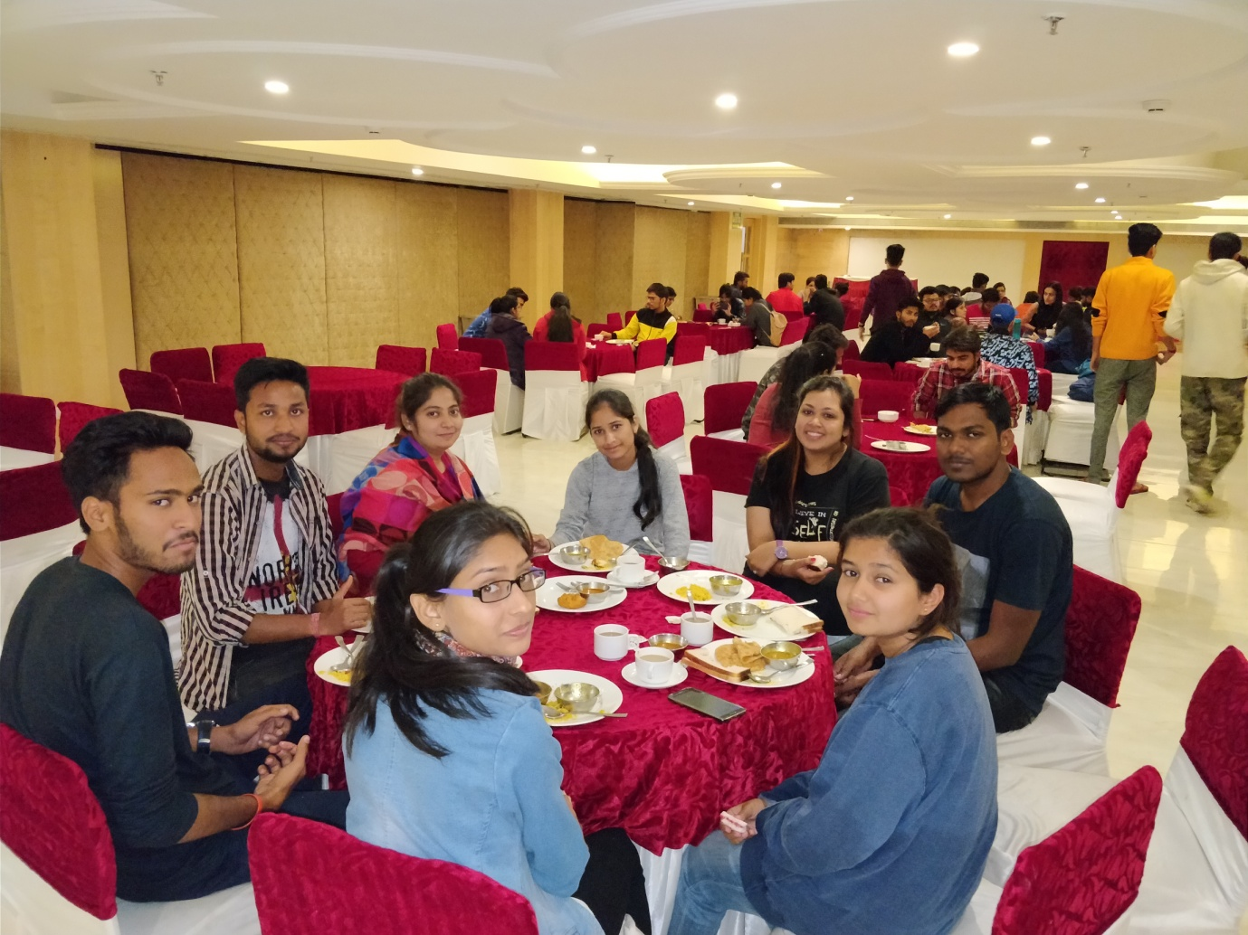

Dinner at Clarion INN

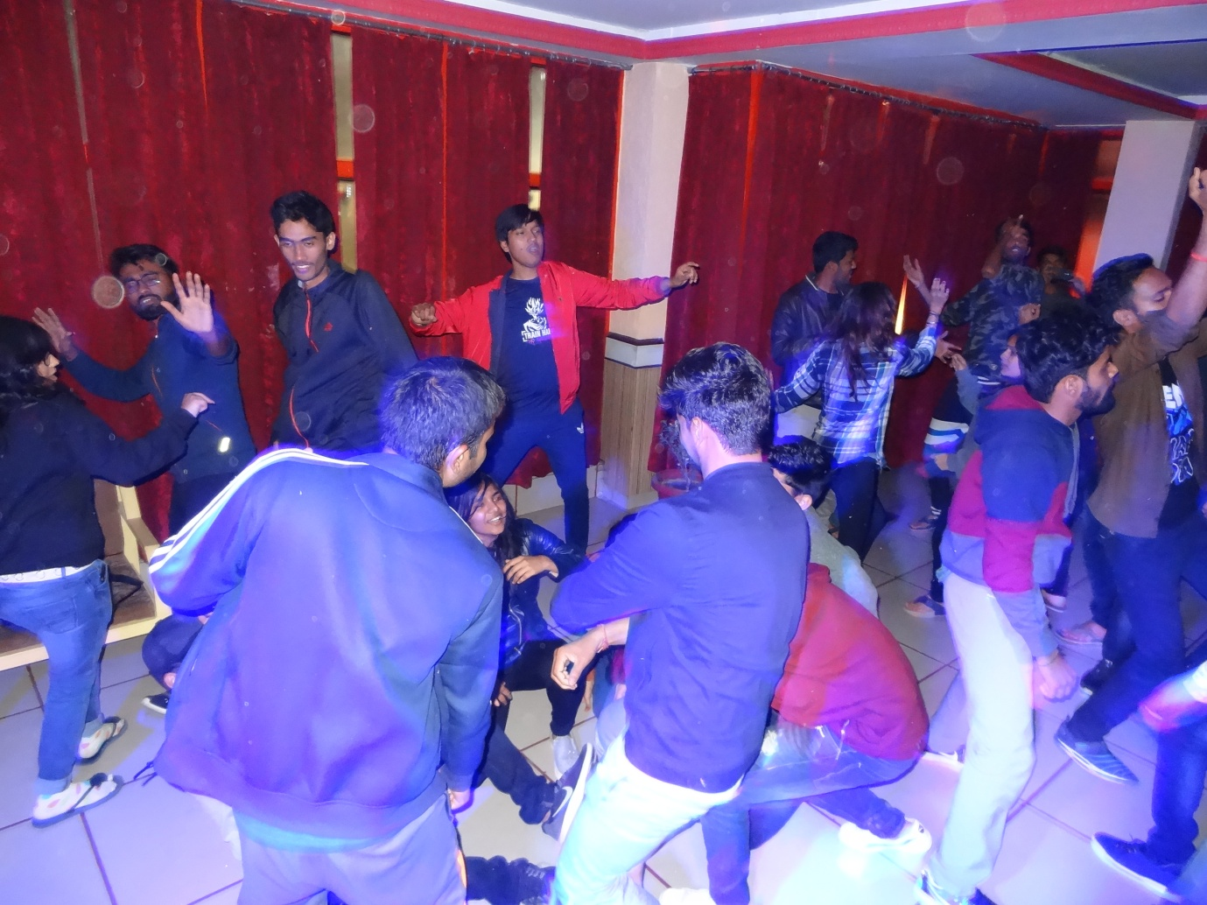

DJ Night at Chandigarh

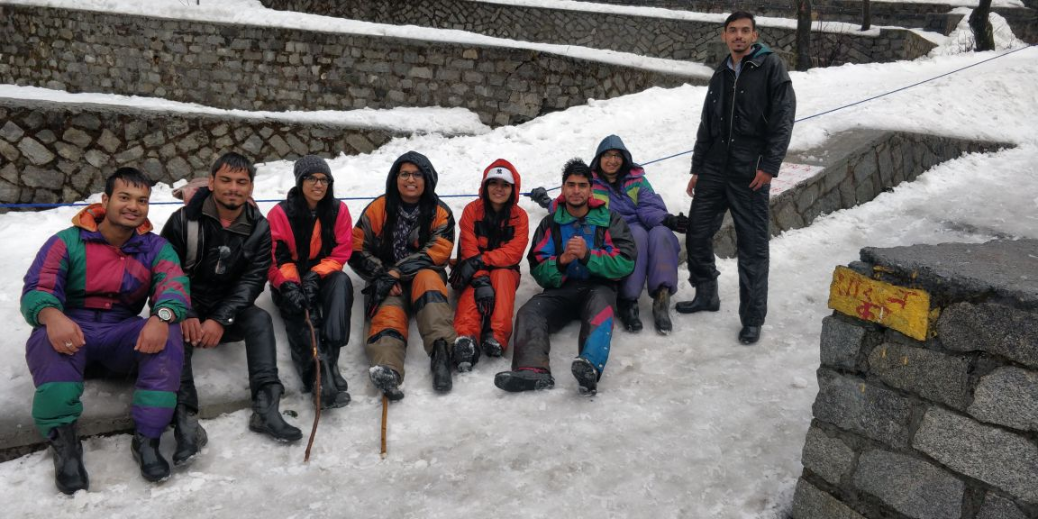

Student at Solang Valley

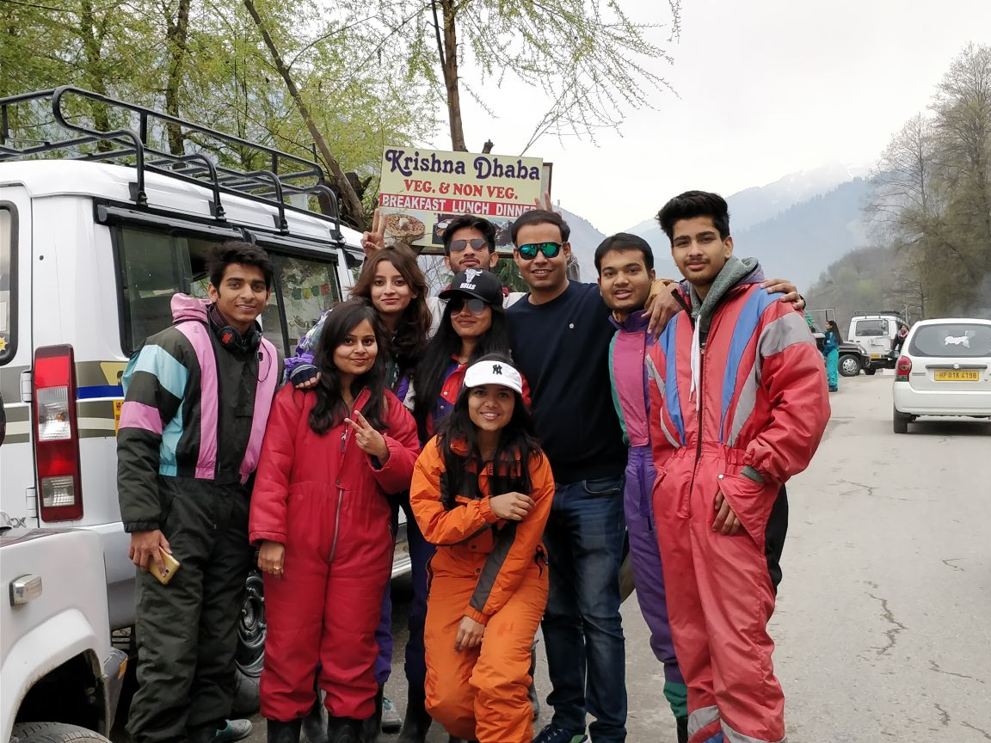

Student at Gulaba